EXPERIMENT 08
PERFORM WEB SPIDERING

1. AIM
To map out the complete page hierarchy, endpoint links, and form input locations of a web application using automated spidering/crawling tools in Burp Suite and OWASP ZAP.

2. THEORY
Web spidering (crawling) recursively follows every hyperlink and parses HTML form definitions to generate a comprehensive sitemap of the target web application.

3. TOOLS REQUIRED
- OWASP ZAP (Spider Tool)
- Burp Suite Target Site Map
- Target Application

4. PROCEDURE & COMMANDS
Step 1: Set Target Scope in OWASP ZAP
Open OWASP ZAP, enter target URL in Quick Start, and define target scope to prevent crawling out-of-scope third-party sites.
Step 2: Execute Automated Web Crawl
Launch the ZAP Spider to automatically discover all accessible application paths:
zaproxy &
Quick Start -> Automated Scan / Spider Target

Step 3: Analyze Site Map Hierarchy & Discovered Endpoints
Expand the Sites tree to inspect discovered directories, GET/POST form parameters, and hidden file paths.
Step 4: Export Discovered URL Inventory
Right-click target root in Sites tree -> Export -> Export URLs to File to generate the parameter target list.

5. LAB OBSERVATIONS & OUTPUT SCREENSHOTS
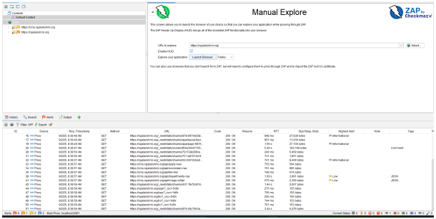

6. EXPECTED OUTPUT RESULT
A complete, structured sitemap containing all discovered application URLs, form inputs, hidden endpoints, and exported parameter lists.

7. VIVA VOICE QUESTIONS & ANSWERS
S.NO & VIVA QUESTION | TECHNICAL ANSWER
Q1. What is web spidering, and why is it done before vulnerability scanning? | Spidering maps all accessible application pages and forms. Vulnerability scanners require this map to know where to send payloads.
Q2. What is the difference between Burp Suite's Spider and OWASP ZAP's Spider? | Burp Spider focuses on passive/active traffic crawling. ZAP Spider is a fully automated open-source crawler that parses links and forms.
Q3. Why is it important to set a defined "scope" before crawling? | Scope keeps the crawler targeted on authorized domains, avoiding unintended scanning of third-party external sites.
Q4. What kind of pages might a spider miss, and why? | Unlinked orphan pages, complex multi-step auth forms, heavy JavaScript AJAX content, and paths blocked in robots.txt.
Q5. How does the site map produced here feed into Experiment 9? | The sitemap provides the exact target URL and parameter inventory used by active scanners to test for vulnerabilities.

